IOT Gas Pipe Leakage Detector Insect Robot
Gas pipes play very important roles for cities, industries and thus in growing economies. So gas leakages lead to losses as well as are a threat because they can also lead to fire accidents. Placing sensors at each section of pipe is very costly. So here we propose an innovative robot that clings on to the outer surface of the gas pipe and moves with the pipe to check for leakages. The robot consists of gas sensor that is used to detect gas leakages. As the robot keeps moving along the metal pipe it keeps monitoring for any gas leakage, On detection it uses an interface gps sensor to transmit location of th leakage detected over to the IOT login system, Here we use IOTgecko to receive and display the gas leakage alert and location over IOT. Thus we have a fully automated insect like robot that moves with the gas pipe and detects gas leakages instantly at a low budget.

Block Diagram :
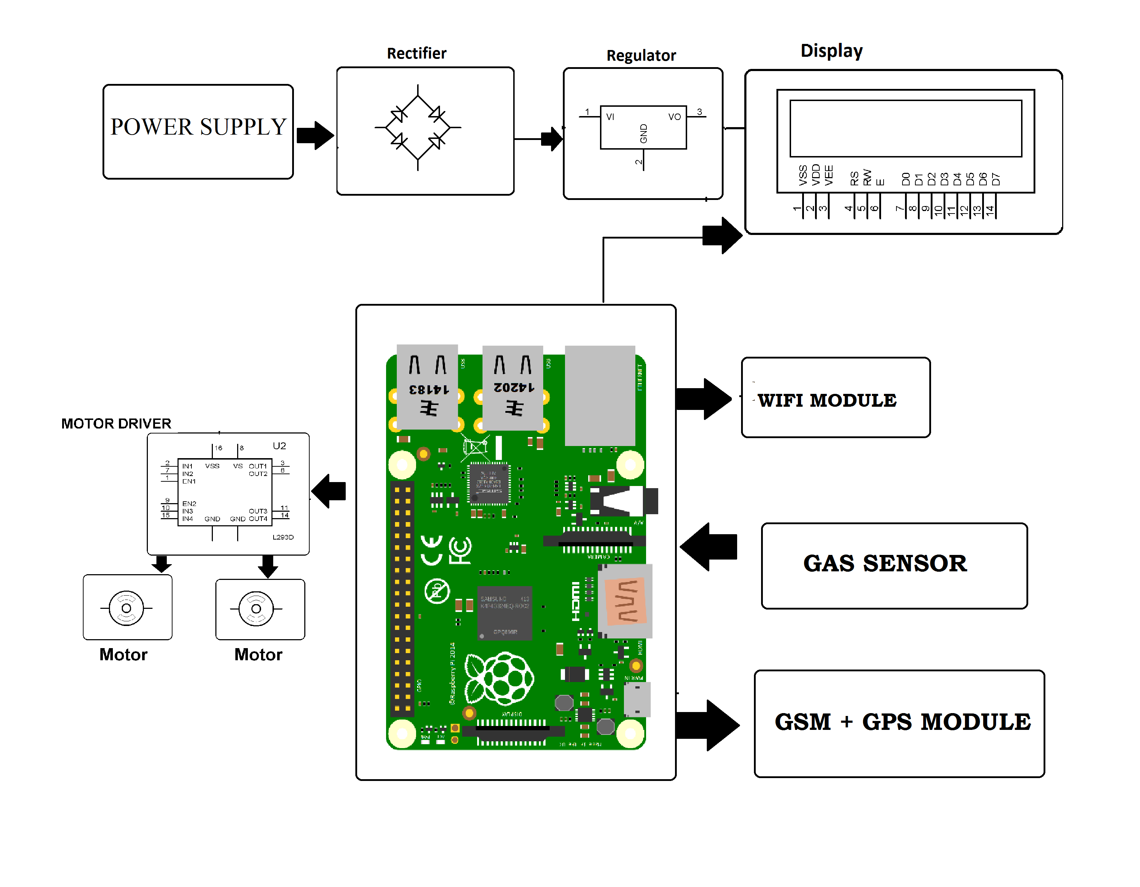

Hardware Specifications :
- Power Supply
- Rectifier
- Regulator
- Buzzer
- Motor Driver
- Raspberry Pi
- DC Motors
- Magnetic Wheels
- Gas Sensor
- GSM & GPS Module

Software Specifications :
- Python compiler
- Programming Language: Python

